CS 255 System Design Document Template

This template lays out all the different sections that you need to complete for Project Two. Each section has guidance to prompt your thinking. You will need to continually reference the interview transcript as you work to make sure that you are addressing your client’s needs. There is no required length for the final document. Instead the goal is to complete each section based on what your client’s needs are. Remove this note when you are finished, and replace all bracketed text with the relevant information.

UML Diagrams

UML Use Case Diagram
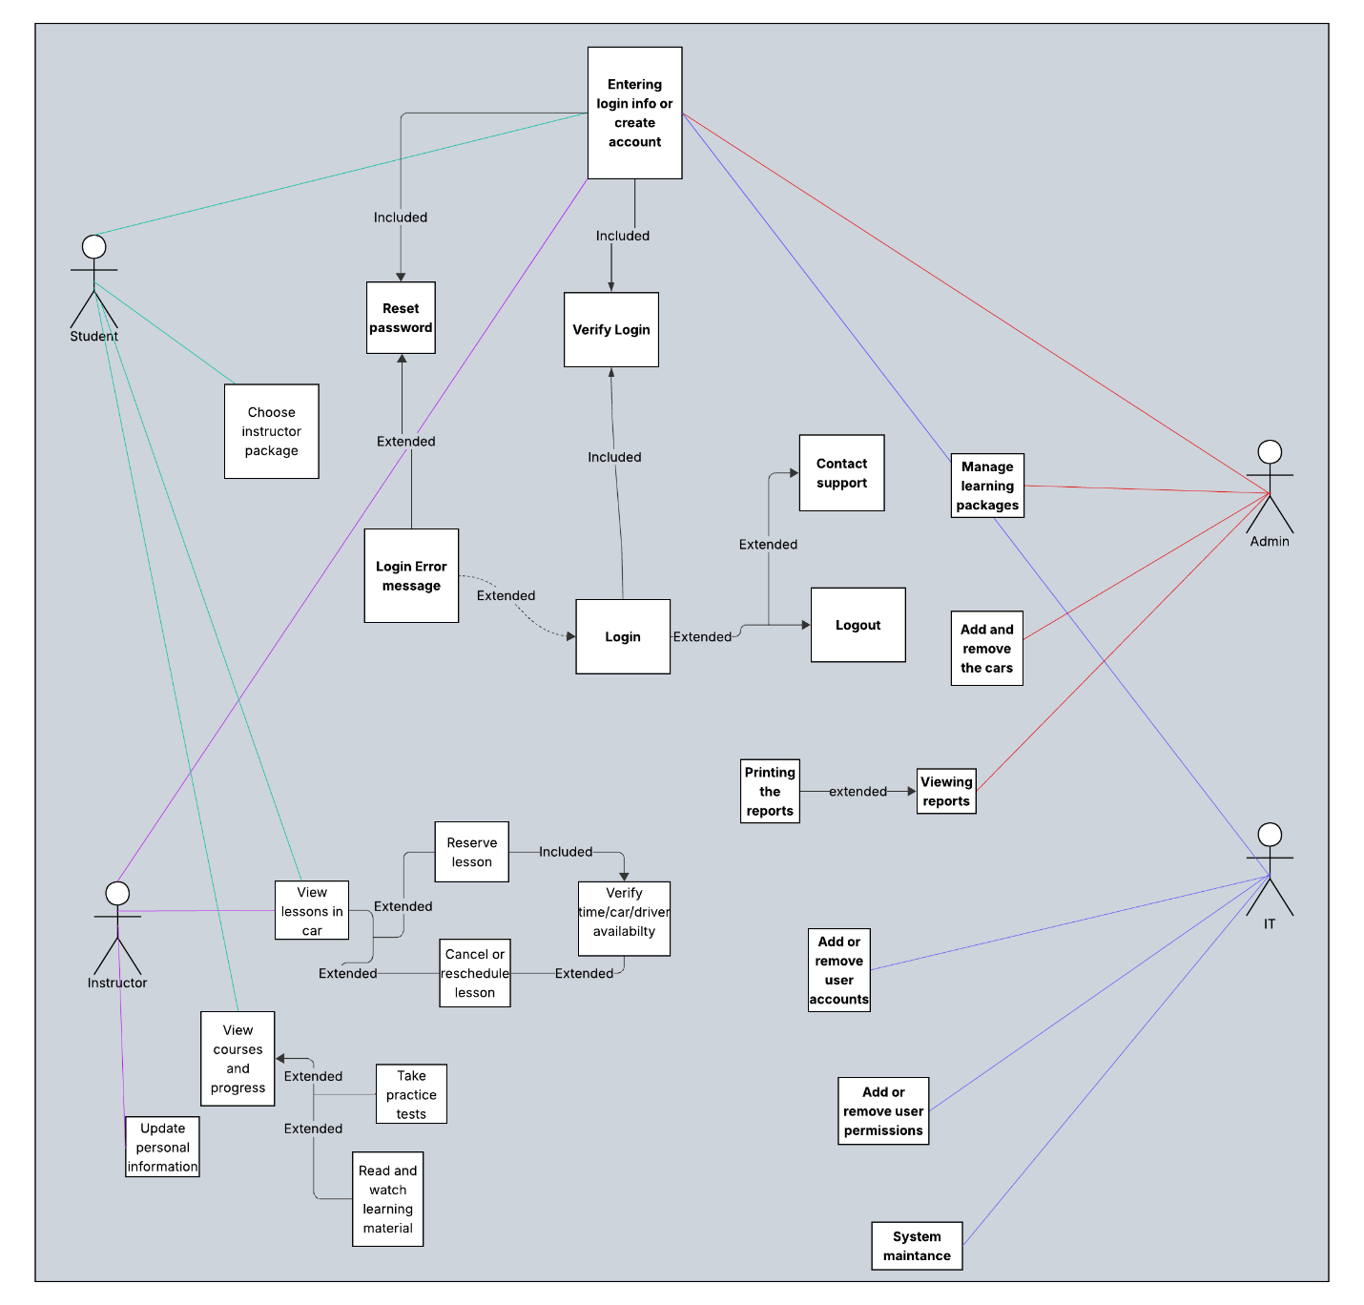

UML Activity Diagrams
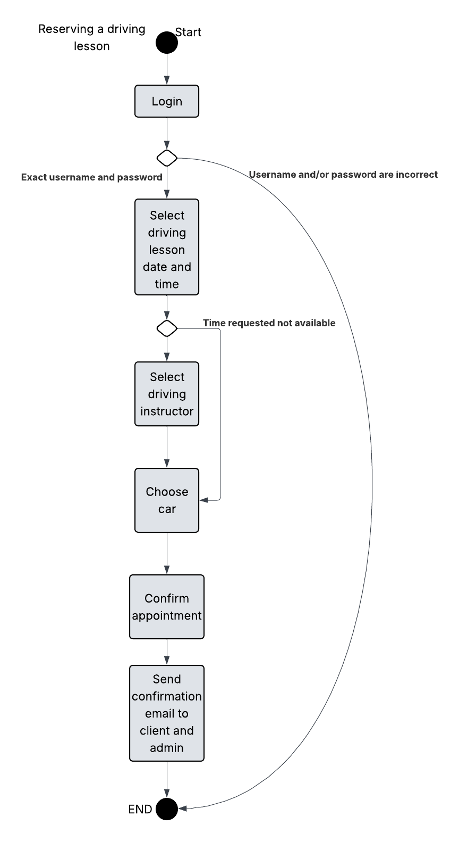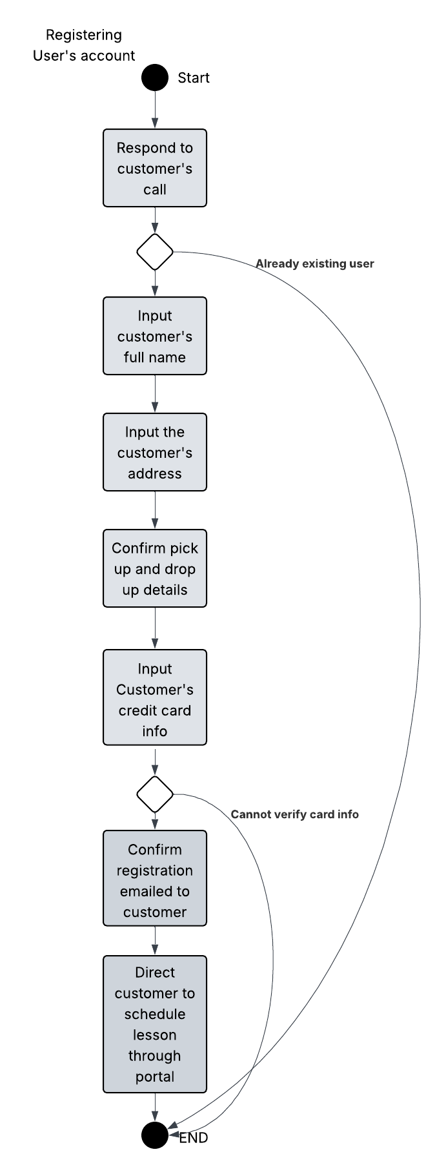

UML Sequence Diagram
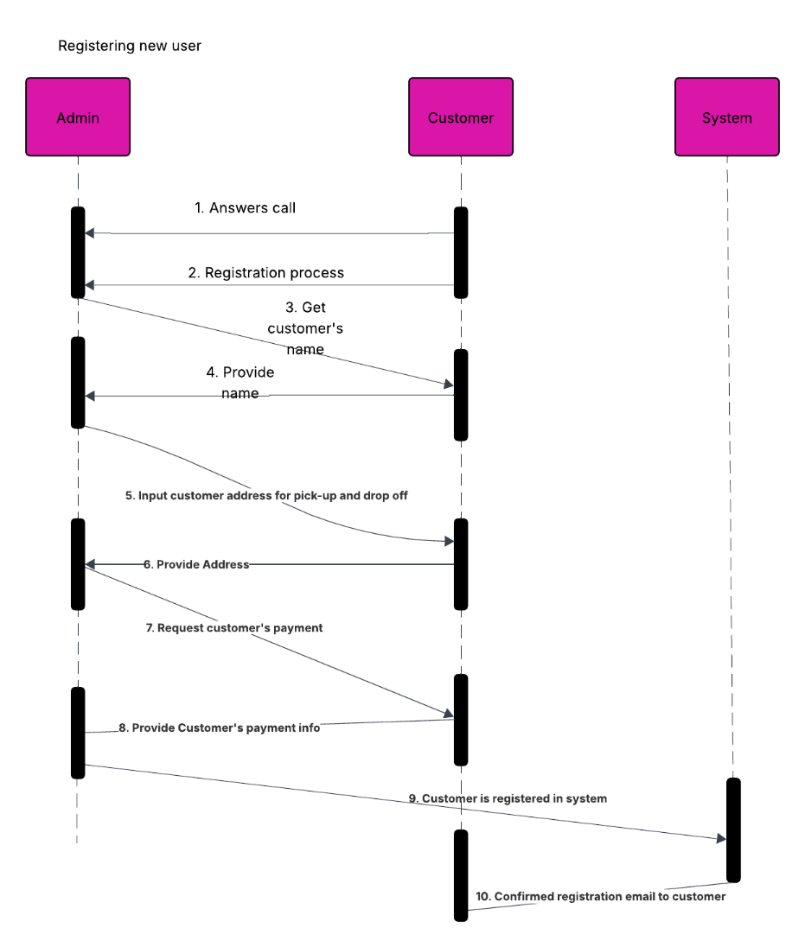

UML Class Diagram
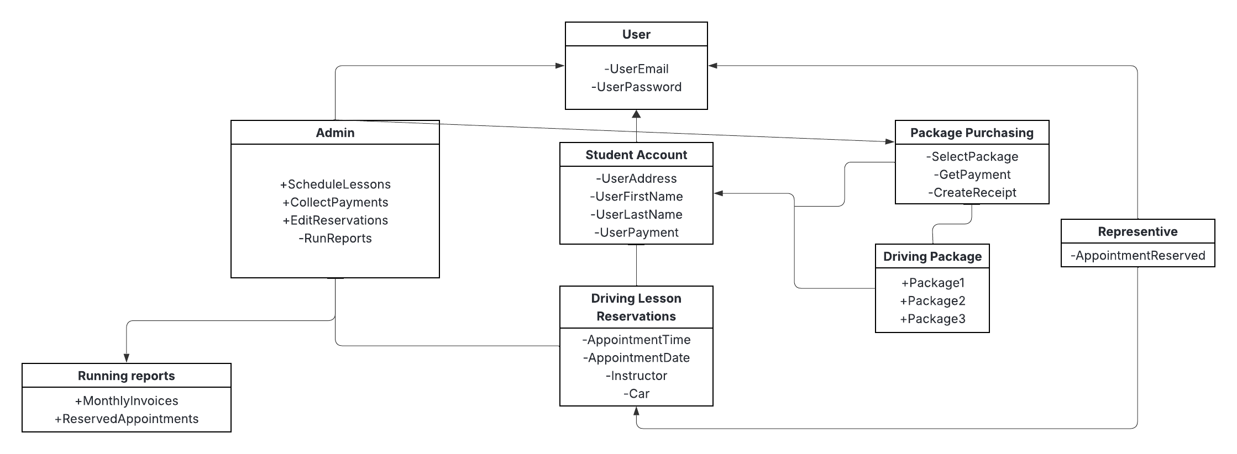

Technical Requirements
DriverPass, despite being a small business, has a lot of room to grow and expand to become the leading force on helping potential drivers succeed in their written and driving tests. Looking at the diagrams above, it is recommended to employ a cloud-based infrastructure that would be cost-effective and allow for expandability in the future if they desire to. On the internal level, it is recommended that all the administrative staff should be using computers that come with the Windows operating system pre-installed. It is also recommended that a backup is to be placed on the database level to maintain any sensitive data of the customers and any administrative information; along with deploying anti-virus software to prevent any malware and virus on the network. A reliable internet service provider is necessary to ensure that the administrative and customers can make changes to their schedules, reservations, and the policies that are submitted from the DMV. The customer shall be able to access the DriverPass portal on the commonly used operating systems such as Android, iOS, MacOS, and Windows platforms to reach a larger quantity of customers for DriverPass.

